ISHAM Working Group Annual Report 2018

- Title of Working Group
Environmental fungal exposure and human health
- Name(s) of Coordinator(s) with email addresses
Coordinator: Prof. Esther Segal, M.Sc., Ph.D., FECMM – ISHAM MM0473;
segale@tauex.tau.ac.il

Co-coordinators:
Dr. João Brandão, ISHAM MM3894; joao.brandao@insa.min-saude.pt
Prof. Jean-Pierre Gangneux, M.D., Ph.D., FECMM - ISHAM MM 3895;
jean-pierre.gangneux@univ-rennes1.fr
- Website URL for external website (if relevant)
n.a.
- Objectives and expected outcomes for the forthcoming year
The overall objective of this project is raising the awareness to fungal contaminants of sand by focusing on the isolation and identification of the fungal flora in sand and water, and by emphasizing implications of the findings on human health and wellbeing. It will help generate data to highlight the importance of the beach as an exposure means to fungal flora, taking into consideration different geographic areas and climatic/environmental conditions of the sampling sites.

The project is also a first step of the risk evaluation that will help to design consensual proposals in terms of surveillance and prevention of risk, and is being operated by different countries around various water bodies, with 28 participating laboratories.

As the project is a new ISHAM Working Group established only late 2018 (September), the full cycle of beach sand/water collection to represent the four sessions of a year could not be fulfilled in 2018.

Thus, the forthcoming year – 2019, should enable to fulfill a full cycle of samples' collection of the 4 seasons of the year.

The specific objectives of the forthcoming year include:
- Continuation of samples' collection from sand/water at the different sites (see paragraph 5 – map of sampling sites).
Culture, quantification and phenotypic identification of the isolated fungi from the collected sand/water samples of 2019.
- Identification by Mass spectroscopic methods - MALDI-TOF of cultures from samples collected in 2018.
- If possible (depending on laboratory), molecular identification (ITS identification) of fungi isolated from samples collected in 2018.
- Preparation for Presentation of accumulated data of the Working Group at the TIMM 2019 Conference in Nice, France (October 2019).
- Achievements of the Working Group in 2018 (250 words) ¹⁻³
- During 2018 we established the working team and sampling sites. The following image outlines the sites in study:
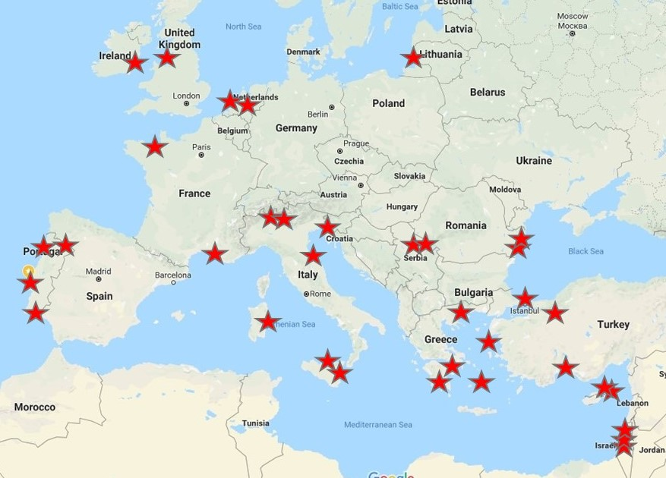

- The SOP was established based on previous experience of some of the participants of the study (available upon request).
- Sampling campaigns: on average, the team executed 3.6 sampling campaigns since the kick-off of the project. The expected number is 12 months of campaigns.
- The team comprised already over 50 % of ISHAM members but the official ISHAM study group yielded 6 new ISHAM registrations up till now.
- Constitution of a joint-WG with the ECMM one, resulting in an expansion of the number of participations and sampling sites
- Submission of a proposal for a symposium during the congress Trends in Medical Mycology – TIMM 9, October 2019 in Nice, France, aiming to present and discuss preliminary results of the project.
- Publications arising from the Working Group
None thus far. Expected late 2019/early 2020
- Funding provided by ISHAM in the past 3 years (Budget and year)
No ISHAM funding was provided, thus far. But an application for ISHAM Funding was submitted November 2018.
- Composition of the working group
Number of working group members: 28 centers
Number of ISHAM members among WG members - 19
¹ The achievement arising from the Working Group with acknowledge its status within ISHAM by explicitly including the phrase “ISHAM Working Group” in all public and professional publications, workshop programs, lectures, its website or similar activities.
² Achievements of the Working Group include but not limited to the following:
- meeting/workshop/training course/symposium of the working group,
- peer-reviewed publication,
- presentation (symposium, oral or poster paper) from working group during ISHAM congress,
- contribute material to the main ISHAM website and its regular newsletter.
- Increase ISHAM members, strengthen link between ISHAM and working group, and enhance visibility of ISHAM.
³ Supporting information for achievements are welcome.

