ISHAM Working Group Annual Report 2018

- Title of Working Group

Malassezia epidemiology and pathobiology
- Name(s) of Coordinator(s) with email addresses
- Teun Boekhout (chair t.boekhout@westerdijkinstitute.nl)
- George Gaitanis (secretary, ggaitan@uoi.gr)
- Annika Scheynius (member, Annika.Scheynius@ki.se)
- Carol Munro (member, a.munro@abdn.ac.uk)

- Website URL for external website (if relevant)
https://www.isham.org/working-groups/working-group-malassezia-epidemiology-and-pathobiology
- Objectives and expected outcomes for the forthcoming year
- Further integration of activities of ISHAM working group and Malassezia research consortium.
- Arranging list of members of the working group
- Planning Malassezia workshop 2020, Singapore

- Achievements of the Working Group in 2018 (250 words) ¹⁻³
The main activity in 2018 has been the organization of a post-ISHAM 2018 workshop in Utrecht.
Malassezia: from skin to model species

From July 4-6, the Westerdijk Fungal Biodiversity Institute, Utrecht, the Netherlands, and ASTAR Singapore hosted a post-ISHAM2018 workshop focusing on Malassezia research. Organizers Teun Boekhout (Westerdijk Fungal Biodiversity Institute, the Netherlands) and Thomas Dawson Jr. (Skin Research Institute of Singapore, A*STAR, Singapore) brought together 65 scientists, clinicians and industry representatives from 25 countries to share expertise and strengthen future Malassezia research. Additionally, this opportunity was used to explore the feasibility of combining forces between the ISHAM Malassezia working group and the Malassezia Research Consortium. Thirty expert and younger scientists shared their latest research and perspectives on Malassezia related topics divided over 4 main themes, 1. Ecology, diversity and microbiome; 2. Host Microbe and Biochemistry; 3. Clinical, Therapy and Diagnostics; 4. Molecular Biology, Genetics and Genomics.
The workshop ended with a general discussion to reflect on topics presented and to explore future needs. A clear need emerged for standardization in various fields of Malassezia research, ranging from better defined taxonomic boundaries, diagnostics guidelines, susceptibility testing, treatment, and model systems for studying Malassezia/host interactions.
To advance the Malassezia field and enhance cross-talk between clinically oriented and basic scientists, a merger of the ISHAM Malassezia working group and the Malassezia Research Consortium was strongly promoted.
A full report on the workshop and a photo of the participants is available at https://www.isham.org/working-groups/working-group-malassezia-epidemiology-and-pathobiology.

In addition, a session was organized at the main ISHAM 2028, Amsterdam congress.

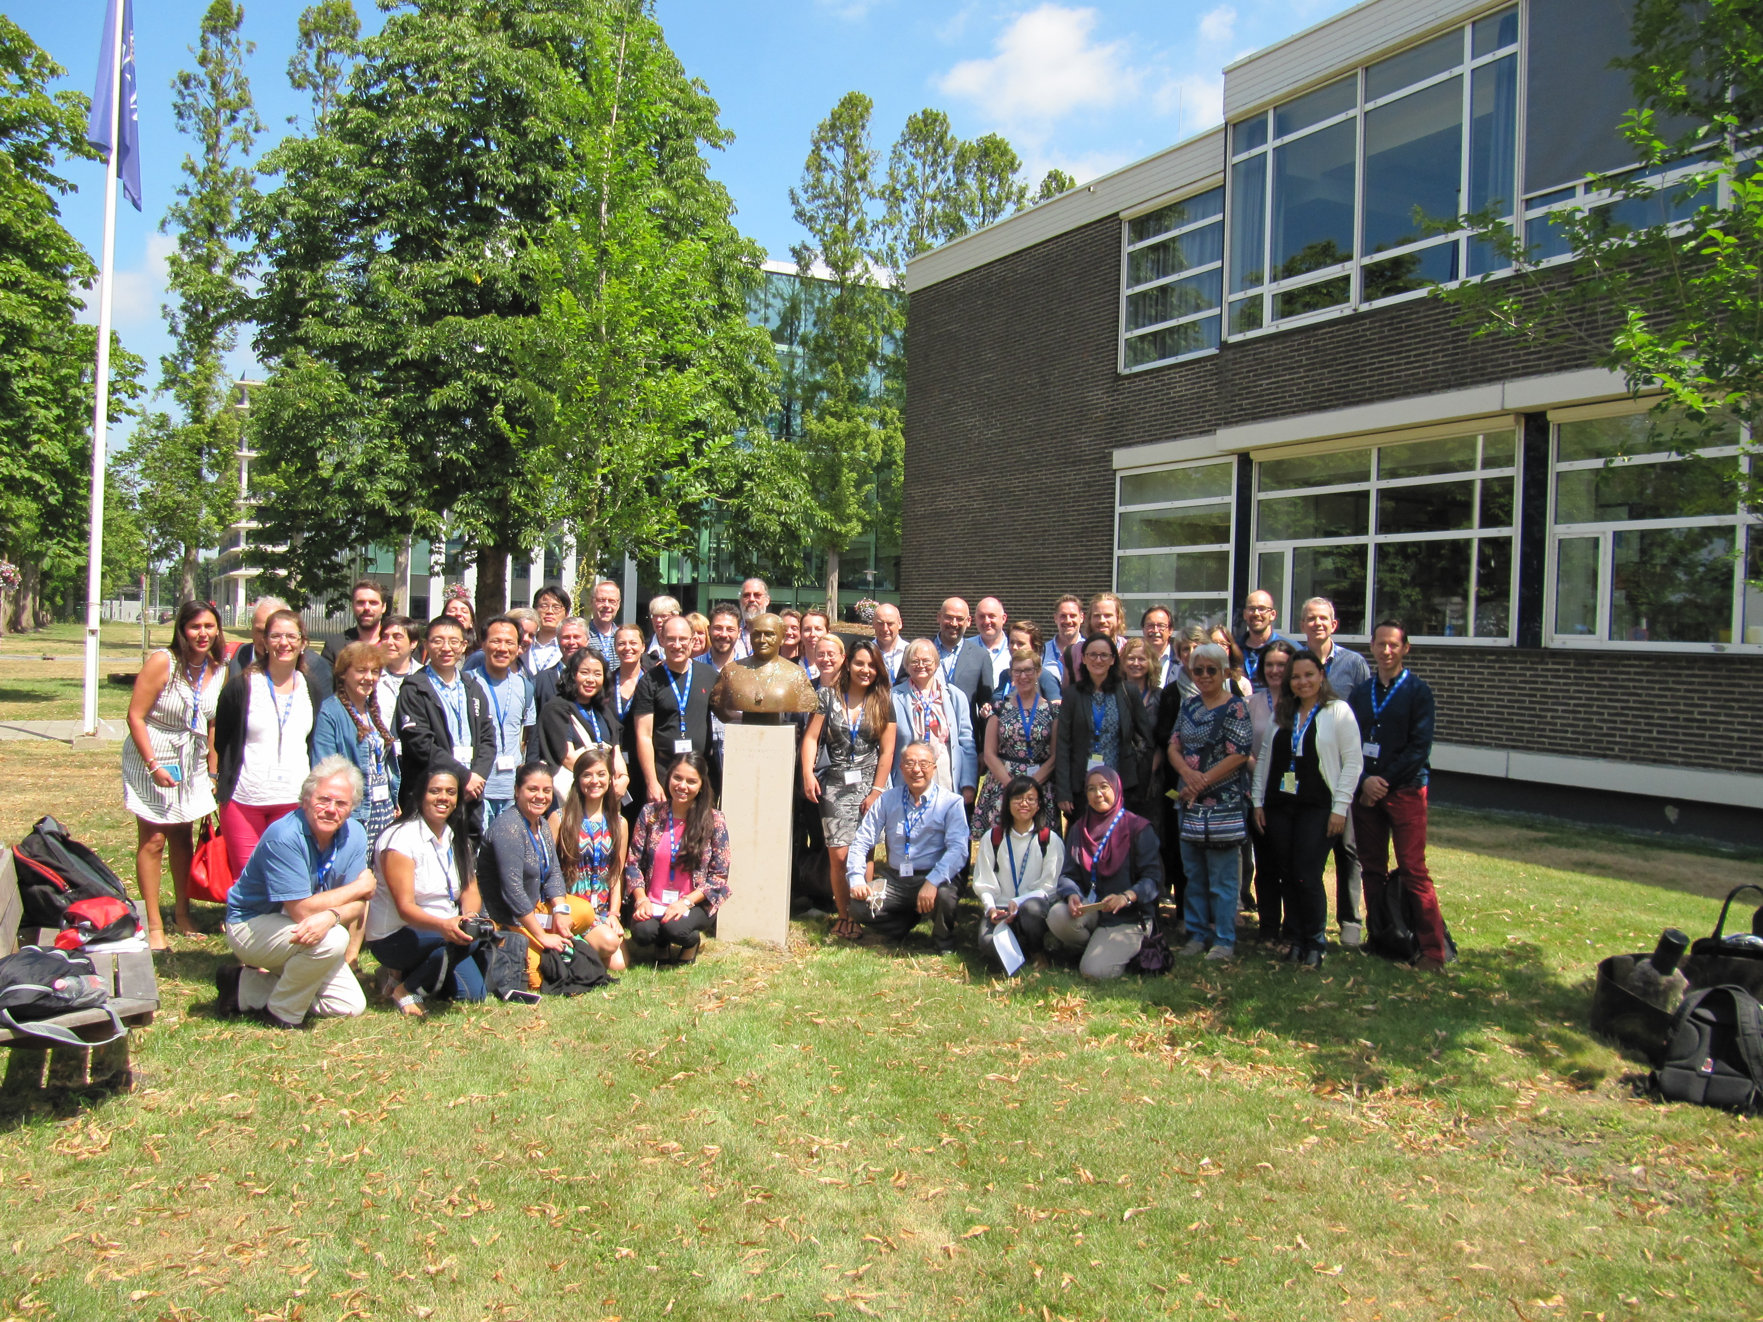

- Publications arising from the Working Group
Theelen, B., Cafarchia, C., Gaitanis, G., Bassukas, I., Boekhout, T. & Dawson, T. (2018). Malassezia ecology, pathophysiology, and treatment: a complex commensal/host relationship. Med. Mycol. 56: S10-S25.
De Hoog, G.S., Monod, M., Dawson, T., Boekhout, T., Mayser, P. & Gräser, Y. (2017) Skin fungi from colonization to infection. Microbiol. Spectrum 5: FUNK-0049-2016

- Funding provided by ISHAM in the past 3 years (Budget and year)
2,500 €, 2018, Malassezia workshop, Utrecht.

- Composition of the working group
Number of working group members; At present there is no list of WG members
Number of ISHAM members among WG members; Unknown

Please complete and return to Dr. Yee-Chun Chen (yeechunchen@gmail.com) by February 7, 2019
Reports will be placed on the ISHAM webpage （https://www.isham.org/working-groups）for the respective working group.

