ISHAM WORKING GROUP: DIGITAL MYCOLOGY – ANNUAL REPORT

Overview and background

The primary purpose of this Working Group will be the development of digital resources that will be available for ISHAM Members and the wider mycological community, that will provide valuable, scientific and educational information on medical mycology. In particular, the Group will identify and develop a range of digital applications that will be run on a not-for-profit basis. One of the goals of the Group will be to raise sufficient funds to develop these resources. We will also identify the developers of existing digital resources (eg. Smart phone apps, teaching videos) to join the Working Group.

## Achievements

The proposed working group will initially focus on three activities. The first of these has been achieved.

1.  Development of an antifungal spectrum of activity app for smart phones and tablets.

There are many excellent websites that contain antifungal susceptibility data in the form of MICs and breakpoints, including the EUCAST-AFST website. Our aim is utilize the open-source data held by EUCAST to develop an easy-to-use smart phone app that will enable the user to quickly find all the relevant susceptibility data for a particular pathogenic fungus whilst on the hospital ward or in the laboratory. For less common pathogens we will use published MIC data, and local data bases where available. Many students also use iPads for their undergraduate and post-graduate studies so the app will be formatted for this platform as well.

The application will comprise a data base of fungal pathogens and antifungal agents that will be searchable through specifically designed interfaces. In the initial phase of the development the following defined parameters will be available on the application.

Information available for each pathogen:

* effective antifungal treatments
* susceptibility and resistance profiles
* reference citations, which can be emailed to colleagues

Information available for each antifungal agent:

* Pathogens that it is effective against
* MICs
* Reference citations
* Funding for this specific Working Group Project will be made in the form of an education grant by Gilead Science Europe. The data base and application will be developed by Synergy Medical (www.synergymedical.co.uk) who have extensive experience in developing digital platforms to execute medical education initiatives. In collaboration with ISHAM, the application will be promoted widely.

Apple App Store downloads:

|  |  |
| --- | --- |
| January, 2017 | 10 |
| February, 2017 | 10 |
| March, 2017 | 11 |
| April, 2017 | 14 |
| May, 2017 | 9 |
| June, 2017 | 8 |
| July, 2017 | 5 |
| August, 2017 | 5 |
| September, 2017 | 10 |
| October, 2017 | 4 |
| November, 2017 | 7 |
| December, 2017 | 5 |
| January, 2018 | 5 |
| February, 2018 | 6 |
| March, 2018 | 6 |
| April, 2018 | 6 |
| May, 2018 | 9 |
| June, 2018 | 0 |

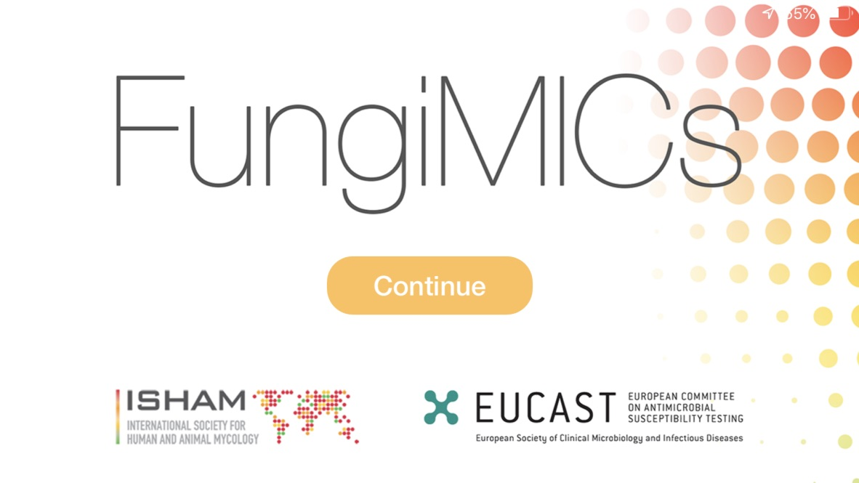 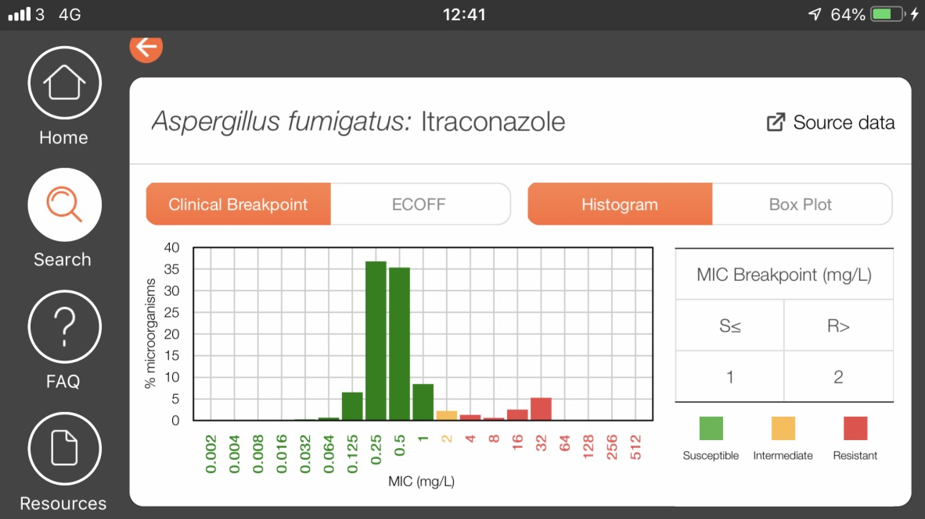

Going forward:

Due to additions and amendments of the EUCAST data base the FungiMic app is obsolete. The developers of the app have been asked for a quotation to revise the content. An application will be made to the ISHAM Council for funding.

Malcolm Richardson

February 2019